Chapter 15
Options Markets

Options provide numerous opportunities to modify the risk profile of a portfolio. The simplest example of an option strategy that increases risk is investing in an ‘all options’ portfolio of at the money options (as illustrated in the text). The leverage provided by options makes this strategy very risky, and potentially very profitable. An example of a risk-reducing options strategy is a protective put strategy. Here, the investor buys a put on an existing stock or portfolio, with exercise price of the put near or somewhat less than the market value of the underlying asset. This strategy protects the value of the portfolio because the minimum value of the stock-plus-put strategy is the exercise price of the put.

- Options at the money have the highest time premium and thus the highest potential for gain. Since they highest potential gain is at the money, the logical conclusion is that they will have the highest volume. A common phrase used by traders is “avoid the cheaps and the deeps.” Cheap options are those with very little time premium. Deep options are those that are way out of or in the money. None of these provide profit opportunities.

- Each contract is for 100 shares: $7.25 × 100 = $725

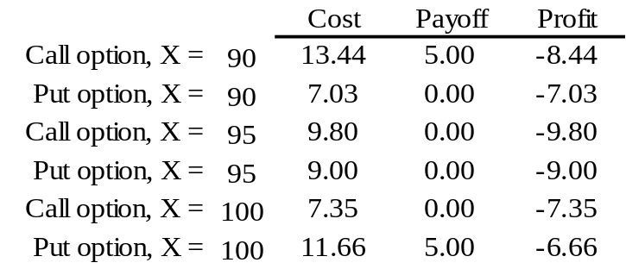

- If the stock price drops to zero, you will make 96.14 – 6.47 per stock, or 89.67. Given 100 units per contract, your total potential profit is $8,967.

- Break even = 40 + 4.50 = 45.50

a. Maximum loss = 4.25 + 5.0 = 9.25
b. Profit / loss = 58 – 50 – 9.25 = -1.25
c. There are two break even prices: 59.25 and 40.75

- c is the only correct statement.

- The collar involves purchasing a put for $3 and selling a call for $2. At all prices your net proceeds will be $39 per share. Given 5,00 shares, you will make 5,000 x 39 = 195,000 when the position is closed.

- In terms of dollar returns:

 | Price of Stock Six Months From Now
Stock price: | $80 | $100 | $110 | $120
All stocks (100 shares) | 8,000 | 10,000 | 11,000 | 12,000
All options (1,000 shares) | 0 | 0 | 10,000 | 20,000
Bills + 100 options | 9,360 | 9,360 | 10,360 | 11,360
In terms of rate of return, based on a $10,000 investment:
 | Price of Stock Six Months From Now
Stock price: | $80 | $100 | $110 | $120
All stocks (100 shares) | -20% | 0% | 10% | 20%
All options (1,000 shares) | -100% | -100% | 0% | 100%
Bills + 100 options | -6.4% | -6.4% | 3.6% | 13.6%

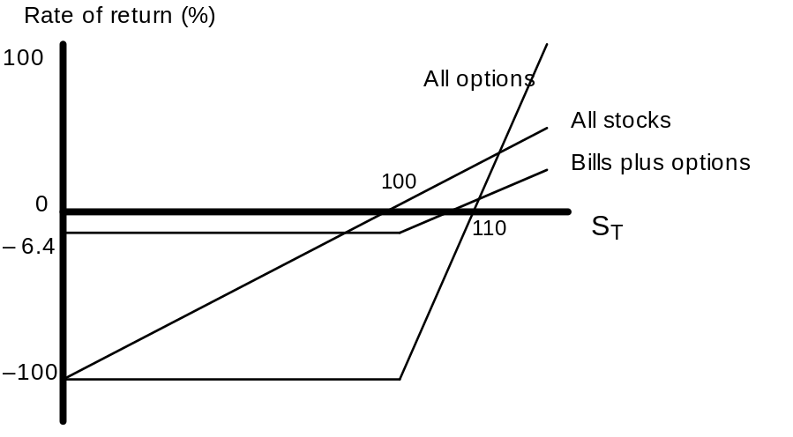

  - Purchase a straddle, i.e., both a put and a call on the stock. The total cost of the straddle would be: $10 + $7 = $17

  - Since the straddle costs $17, this is the amount by which the stock would have to move in either direction for the profit on either the call or the put to cover the investment cost (not including time value of money considerations).

- Sell a straddle, i.e., sell a call and a put to realize premium income of:
$4 + $7 = $11

- If the stock ends up at $50, both of the options will be worthless and your profit will be $11. This is your maximum possible profit since, at any other stock price, you will have to pay off on either the call or the put. The stock price can move by $11 (your initial revenue from writing the two at-the-money options) in either direction before your profits become negative.

- Buy the call, sell (write) the put, lend the present value of $50. The payoff is as follows:
 |  | Final Payoff
Position | Initial Outlay | S_{T} < X | S_{T} > X
Long call | C = 7 | 0 | S_{T} – 50
Short put | -P = -4 | -(50 – S_{T}) | 0
Lending | 50/(1 + r)^{(1/4)} | 50 | 50
Total | 7 – 4 + [50/(1 + r)^{(1/4)}] | S_{T} | S_{T}
The initial outlay equals: (the present value of $50) + $3
In either scenario, you end up with the same payoff as you would if you bought the stock itself.

- By writing covered call options, Jones receives premium income of $30,000. If, in January, the price of the stock is less than or equal to $45, he will keep the stock plus the premium income. Since the stock will be called away from him if its price exceeds $45 per share, the most he can have is:
$450,000 + $30,000 = $480,000
(We are ignoring interest earned on the premium income from writing the option over this short time period.) The payoff structure is:
Stock price | Portfolio value
Less than $45 | (10,000 times stock price) + $30,000
Greater than $45 | $450,000 + $30,000 = $480,000
This strategy offers some premium income but leaves the investor with substantial downside risk. At the extreme, if the stock price falls to zero, Jones would be left with only $30,000. This strategy also puts a cap on the final value at $480,000, but this is more than sufficient to purchase the house.

- By buying put options with a $35 strike price, Jones will be paying $30,000 in premiums in order to insure a minimum level for the final value of his position. That minimum value is: ($35 × 10,000) – $30,000 = $320,000
This strategy allows for upside gain, but exposes Jones to the possibility of a moderate loss equal to the cost of the puts. The payoff structure is:
Stock price | Portfolio value
Less than $35 | $350,000 – $30,000 = $320,000

Greater than $35 | (10,000 times stock price) – $30,000

- The net cost of the collar is zero. The value of the portfolio will be as follows:
Stock price | Portfolio value
Less than $35 | $350,000
Between $35 and $45 | 10,000 times stock price
Greater than $45 | $450,000
If the stock price is less than or equal to $35, then the collar preserves the $350,000 in principal. If the price exceeds $45, then Jones gains up to a cap of $450,000. In between $35 and $45, his proceeds equal 10,000 times the stock price.
The best strategy in this case is (c) since it satisfies the two requirements of preserving the $350,000 in principal while offering a chance of getting $450,000. Strategy (a) should be ruled out because it leaves Jones exposed to the risk of substantial loss of principal.
Our ranking is: (1) c (2) b (3) a

- Butterfly Spread
Position | S < X1 | X1 < S < X2 | X2 < S < X3 | X3 < S
Long call (X1) | 0 | S – X1 | S – X1 | S – X1
Short 2 calls (X2) | 0 | 0 | –2(S – X2) | –2(S – X2)
Long call (X3) | 0 | 0 | 0 | S – X3
Total | 0 | S – X1 | 2X2 – X1 – S | (X2–X1 ) – (X3–X2) = 0

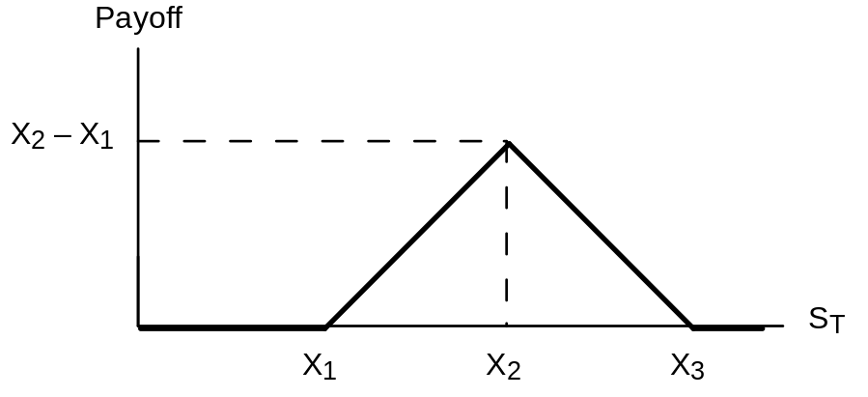

- Vertical combination
Position | S < X1 | X1 < S < X2 | S > X2
Long call (X2) | 0 | 0 | S – X2
Long put (X1) | X1 – S | 0 | 0
Total | X1 – S | 0 | S – X2

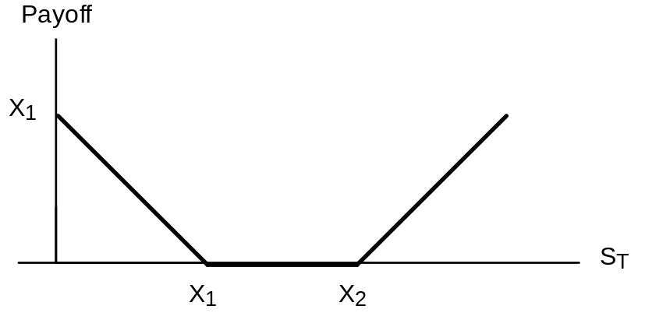

- Bearish spread
Position | S < X1 | X1 < S < X2 | S > X2
Long call (X2) | 0 | 0 | S – X2
Short call (X1) | 0 | –(S – X1) | –(S – X1)
Total | 0 | X1 – S | X1 – X2

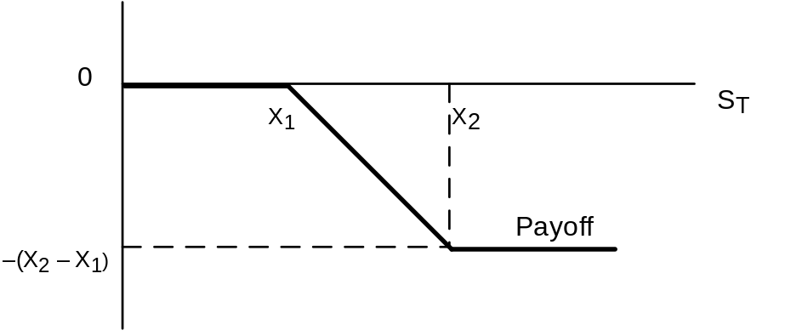

In the bullish spread, the payoff either increases or is unaffected by stock price increases. In the bearish spread, the payoff either increases or is unaffected by stock price decreases.

- .
Protective Put | ST < 1040 | ST > 1040
Stock | ST | ST
Put | 1040 – ST | 0
Total | 1040 | ST

Bills and Call | ST < 1120 | ST > 1120
Bills | 1120 | 1120

Call | 0 | ST – 1120
Total | 1120 | ST

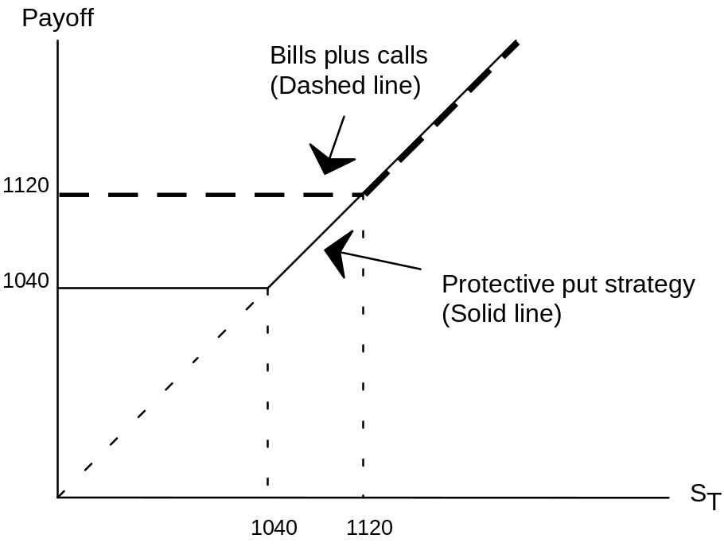

- The bills plus call strategy has a greater payoff for some values of ST and never a lower payoff. Since its payoffs are always at least as attractive and sometimes greater, it must be more costly to purchase.

- The initial cost of the stock plus put position is $1,208 and the cost of the bills plus call position is $1,240.
Position | ST = 0 | ST = 1040 | ST = 1120 | ST = 1200 | ST = 1280
Stock | 0 | 1040 | 1120 | 1200 | 1280
+ Put | 1040 | 0 | 0 | 0 | 0
Payoff | 1040 | 1040 | 1120 | 1200 | 1280
Profit | -168 | -168 | -88 | -8 | +72
Position | ST = 0 | ST = 1040 | ST = 1120 | ST = 1200 | ST = 1280
Bill | 1120 | 1120 | 1120 | 1120 | 1120
+ Call | 0 | 0 | 0 | 80 | 160
Payoff | 1120 | 1120 | 1120 | 1200 | 1280
Profit | -120 | -120 | -120 | -40 | +40

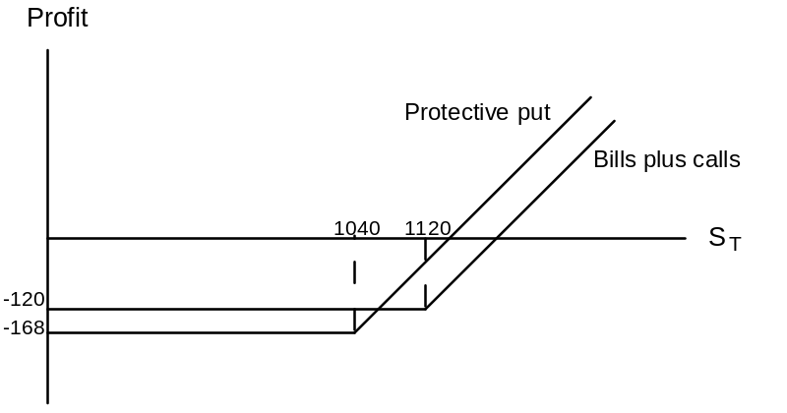

- The stock and put strategy is riskier. It does worse when the market is down, and better when the market is up. Therefore, its beta is higher.

- The Excel spreadsheet for both parts (a) and (b) is shown on the next page, and the profit diagrams are on the following page.

a. & b.
Stock Prices
Beginning Market Price | 116.5
Ending Market Price | 130 |  |  |  |  | X 130 Straddle
 |  |  |  |  | Ending | Profit
Buying Options: |  |  |  |  | Stock Price | -37.20
Call Options Strike | Price | Payoff | Profit | Return % | 50 | 42.80
110 | 22.80 | 20.00 | -2.80 | -12.28% | 60 | 32.80
120 | 16.80 | 10.00 | -6.80 | -40.48% | 70 | 22.80
130 | 13.60 | 0.00 | -13.60 | -100.00% | 80 | 12.80
140 | 10.30 | 0.00 | -10.30 | -100.00% | 90 | 2.80
 |  |  |  |  | 100 | -7.20
Put Options Strike | Price | Payoff | Profit | Return % | 110 | -17.20
110 | 12.60 | 0.00 | -12.60 | -100.00% | 120 | -27.20
120 | 17.20 | 0.00 | -17.20 | -100.00% | 130 | -37.20
130 | 23.60 | 0.00 | -23.60 | -100.00% | 140 | -27.20
140 | 30.50 | 10.00 | -20.50 | -67.21% | 150 | -17.20
 |  |  |  |  | 160 | -7.20
Straddle | Price | Payoff | Profit | Return % | 170 | 2.80
110 | 35.40 | 20.00 | -15.40 | -43.50% | 180 | 12.80
120 | 34.00 | 10.00 | -24.00 | -70.59% | 190 | 22.80
130 | 37.20 | 0.00 | -37.20 | -100.00% | 200 | 32.80
140 | 40.80 | 10.00 | -30.80 | -75.49% | 210 | 42.80

Selling Options: |  |  |  |  |  | Bullish
Call Options Strike | Price | Payoff | Profit | Return % | Ending | Spread
110 | 22.80 | -20 | 2.80 | 12.28% | Stock Price | 6.80
120 | 16.80 | -10 | 6.80 | 40.48% | 50 | -3.2
130 | 13.60 | 0 | 13.60 | 100.00% | 60 | -3.2
140 | 10.30 | 0 | 10.30 | 100.00% | 70 | -3.2
 |  |  |  |  | 80 | -3.2
Put Options Strike | Price | Payoff | Profit | Return % | 90 | -3.2
110 | 12.60 | 0 | 12.60 | 100.00% | 100 | -3.2
120 | 17.20 | 0 | 17.20 | 100.00% | 110 | -3.2
130 | 23.60 | 0 | 23.60 | 100.00% | 120 | -3.2
140 | 30.50 | 10 | 40.50 | 132.79% | 130 | 6.8
 |  |  |  |  | 140 | 6.8
Money Spread | Price | Payoff | Profit |  | 150 | 6.8
Bullish Spread |  |  |  |  | 160 | 6.8
Purchase 120 Call | 16.80 | 10.00 | -6.80 |  | 170 | 6.8
Sell 130 Call | 13.60 | 0 | 13.60 |  | 180 | 6.8
Combined Profit |  | 10.00 | 6.80 |  | 190 | 6.8
 |  |  |  |  | 200 | 6.8
 |  |  |  |  | 210 | 6.8

Spreads and Straddles
-50.00
-40.00
-30.00
-20.00
-10.00
0.00
10.00
20.00
30.00
40.00
50.00
0
50
100
150
200
250
Stock Price
130 Straddle
Bullish Spread

- The bondholders have, in effect, made a loan which requires repayment of B dollars, where B is the face value of bonds. If, however, the value of the firm (V) is less than B, then the loan is satisfied by the bondholders taking over the firm. In this way, the bondholders are forced to “pay” B (in the sense that the loan is cancelled) in return for an asset worth only V. It is as though the bondholders wrote a put on an asset worth V, with exercise price B. Alternatively, one can view the bondholders as giving to the equity holders the right to reclaim the firm by paying off the B dollar debt. The bondholders have issued a call to the equity holders.

- The executive receives a bonus if the stock price exceeds a certain value, and receives nothing otherwise. This is the same as the payoff to a call option.

Position | S < 95 | 95 < S < 100 | S > 100
Short call | 0 | 0 | – (S – 100)
Short put | – (95 –S) | 0 | 0
Total | S – 95 | 0 | 100 – S

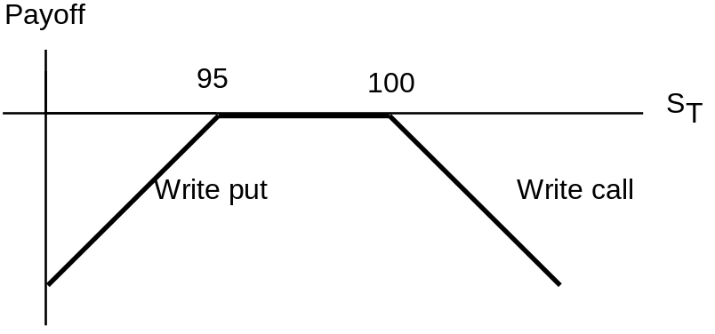

- Proceeds from writing options (from Figure 15.1):
Call = $7.35
Put = $9.00
Total = $16.35
If IBM is selling at $97, both options expire out of the money, and profit equals $16.35. If IBM is selling at $105, the call written results in a cash outflow of $5 at maturity, and an overall profit of: $16.35 – $5.00 = $11.35

- You break even when either the short position in the put or the short position in the call results in a cash outflow of $16.35. For the put, this requires that:
$16.35 = $95 – S ⇒ S = $78.65
For the call this requires that:
$16.35 = S – $100 ⇒ S = $116.35

- The investor is betting that the IBM stock price will have low volatility. This position is similar to a straddle.

- The put with the higher exercise price must cost more. Therefore, the net outlay to establish the portfolio is positive.

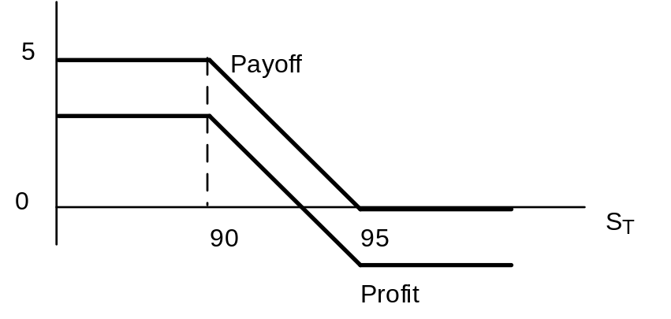

- Buy the X = 62 put (which should cost more than it does) and write the X = 60 put. Since the options have the same price, the net outlay is zero. Your proceeds at maturity may be positive, but cannot be negative.
Position | ST < 60 | 60 < ST < 62 | ST > 62
Long put (X = 62) | 62 – ST | 62 – ST | 0
Short put (X = 60) | – (60 – ST) | 0 | 0
Total | 2 | 62 – ST | 0

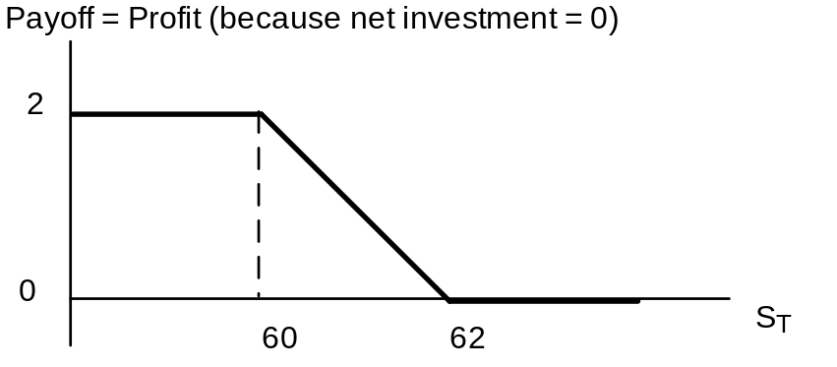

- The following payoff table shows that the portfolio is riskless with time-T value equal to $10. Therefore, the risk-free rate is: ($10/$9.50) – 1 = 0.0526 = 5.26%
Position | ST < 10 | ST > 10
Buy stock | ST | ST
Short call | 0 | – (ST – 10)
Long put | 10 – ST | 0
Total | 10 | 10

- Joe’s strategy
 |  | Final Payoff
Position | Initial Outlay | S_{T} < 1200 | S_{T} > 1200
Stock index | 1200 | S_{T} | S_{T}
Long put (X = 1200) | 60 | 1200 – S_{T} | 0
Total | 1260 | 1200 | S_{T}
Profit = payoff – 1260 |  | -60 | S_{T} – 1260
Sally’s Strategy
 |  | Final Payoff
Position | Initial Outlay | S_{T} < 1170 | S_{T} > 1170
Stock index | 1200 | S_{T} | S_{T}
Long put (X = 1170) | 45 | 1170 – S_{T} | 0
Total | 1260 | 1170 | S_{T}
Profit = payoff – 1245 |  | -75 | S_{T} – 1245

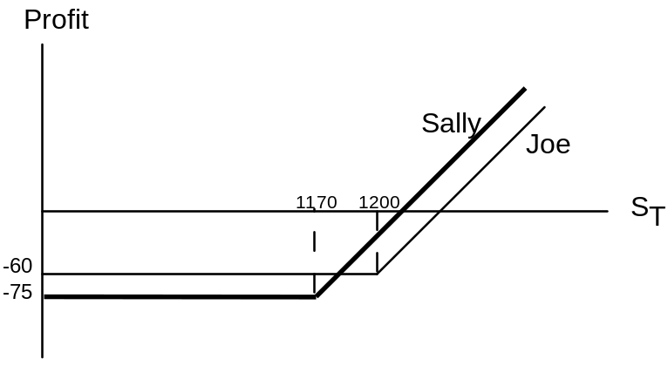

- Sally does better when the stock price is high, but worse when the stock price is low. (The break-even point occurs at S = $1185, when both positions provide losses of $60.)

- Sally’s strategy has greater systematic risk. Profits are more sensitive to the value of the stock index.

- This strategy is a bear spread. The initial proceeds are: $9 – $3 = $6

The payoff is either negative or zero:
Position | ST < 50 | 50 < ST < 60 | ST > 60
Long call (X = 60) | 0 | 0 | ST – 60
Short call (X = 50) | 0 | – (ST – 50) | – (ST – 50)
Total | 0 | – (ST – 50) | –10

Breakeven occurs when the payoff offsets the initial proceeds of $6, which occurs at a stock price of ST = $56.

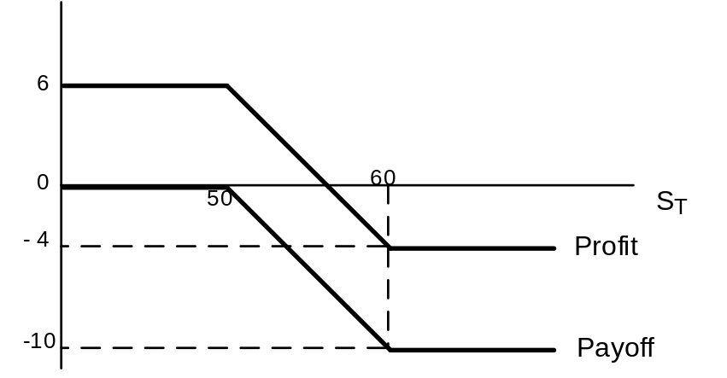

- Buy a share of stock, write a call with X = 50, write a call with X = 60, and buy a call with X = 110.

Position | ST < 50 | 50 < ST < 60 | 60 < ST < 110 | ST > 110
Buy stock | ST | ST | ST | ST
Short call (X = 50) | 0 | – (ST – 50) | – (ST – 50) | – (ST – 50)
Short call (X = 60) | 0 | 0 | – (ST – 60) | – (ST – 60)
Long call (X = 110) | 0 | 0 | 0 | ST – 110
Total | ST | 50 | 110 – ST | 0
The investor is making a volatility bet. Profits will be highest when volatility is low so that the stock price ends up in the interval between $50 and

- The farmer has the option to sell the crop to the government, for a guaranteed minimum price, if the market price is too low. If the support price is denoted PS and the market price PM then we can say that the farmer has a put option to sell the crop (the asset) at an exercise price of PS even if the market price of the underlying asset (P_{M}) is less than PS.

CFA 1

c is false. This is the description of the payoff to a put, not a call.

CFA 2
  - Donie should choose the long strangle strategy. A long strangle option strategy consists of buying a put and a call with the same expiration date and the same underlying asset, but different exercise prices. In a strangle strategy, the call has an exercise price above the stock price and the put has an exercise price below the stock price. An investor who buys (goes long) a strangle expects that the price of the underlying asset (TRT Materials in this case) will either move substantially below the exercise price on the put or above the exercise price on the call. With respect to TRT, the long strangle investor buys both the put option and the call option for a total cost of $9.00, and will experience a profit if the stock price moves more than $9.00 above the call exercise price or more than $9.00 below the put exercise price. This strategy would enable Donie's client to profit from a large move in the stock price, either up or down, in reaction to the expected court decision.

i. The maximum possible loss per share is $9.00, which is the total cost of the two options ($5.00 + $4.00).
ii. The maximum possible gain is unlimited if the stock price moves outside the breakeven range of prices.
iii. The breakeven prices are $46.00 and $69.00. The put will just cover costs if the stock price finishes $9.00 below the put exercise price ($55 − $9 = $46), and the call will just cover costs if the stock price finishes $9.00 above the call exercise price ($60 + $9 = $69).

CFA 3

  - If an investor buys a call option and writes a put option on a T-bond, then, at maturity, the total payoff to the position is (ST – X), where ST is the price of the T-bond at the maturity date (time T) and X is the exercise price of the options. This is equivalent to the profit on a forward or futures position with futures price X. If you choose an exercise price (X) equal to the current T-bond futures price, then the profit on the portfolio replicates that of market-traded futures.

  - Such a position would increase the portfolio duration, just as adding a T-bond futures contract increases duration. As interest rates fall, the portfolio increases in value, so that duration is longer than it was before the synthetic futures position was established.

  - Futures can be bought and sold very cheaply and quickly. They give the manager flexibility to pursue strategies or particular bonds that seem attractively priced without worrying about the impact of these actions on portfolio duration. The futures can be used to make adjustments to duration necessitated by other portfolio actions.

CFA 4

  - Conversion value of a convertible bond is the value of the security if it is converted immediately. That is:

Conversion value = market price of common stock × conversion ratio
= $40 × 22 = $880

  - Market conversion price is the price that an investor effectively pays for the common stock if the convertible bond is purchased:

Market conversion price = market price of the convertible bond/conversion ratio
= $1,050/22 = $47.73
CFA 5
a.

i. The current market conversion price is computed as follows:
Market conversion price = market price of the convertible bond/conversion ratio
= $980/25 = $39.20
ii. The expected one-year return for the Ytel convertible bond is:
Expected return = [(end of year price + coupon)/current price] – 1
= [($1,125 + $40)/$980] – 1 = 0.1888 = 18.88%
iii. The expected one-year return for the Ytel common equity is:
Expected return = [(end of year price + dividend)/current price] – 1
= ($45/$35) – 1 = 0.2857 = 28.57%

b.
The two components of a convertible bond’s value are:
- the straight bond value, which is the convertible bond’s value as a bond, and;
- the option value, which is the value associated with the potential conversion into equity.
i. In response to the increase in Ytel’s common equity price, the straight bond value should stay the same and the option value should increase.
The increase in equity price does not affect the straight bond value component of the Ytel convertible. The increase in equity price increases the option value component significantly, because the call option becomes deep “in the money” when the $51 per share equity price is compared to the convertible’s conversion price of: $1,000/25 = $40 per share.
ii. In response to the increase in interest rates, the straight bond value should decrease and the option value should increase.
The increase in interest rates decreases the straight bond value component (bond values decline as interest rates increase) of the convertible bond and increases the value of the equity call option component (call option values increase as interest rates increase). This increase may be small or even unnoticeable when compared to the change in the option value resulting from the increase in the equity price.

